**Project Report Template**

**TITLE: JOB APPLICATION TRACKING SYSTEM**

**1. INTRODUCTION**

* 1. **Overview**

Create a CRM Application which helps the applicant to track the No. of job the applied and helps him to find the job posted by the various recruiters, find the best attributes to be involved to run the process in a Smooth Way and easily to track.

* 1. **Purpose**

*An ATS allows recruiters to match Job requisitions to the job-posting sites and the social media channels most appropriate for specific candidates.

*An also maximizes visibility for internal job boards.

* While requiring fewer clicks and eliminating barriers for prospective employers.

**2.** **Problem Definition & Design Thinking**

**2.1 Empathy Map**

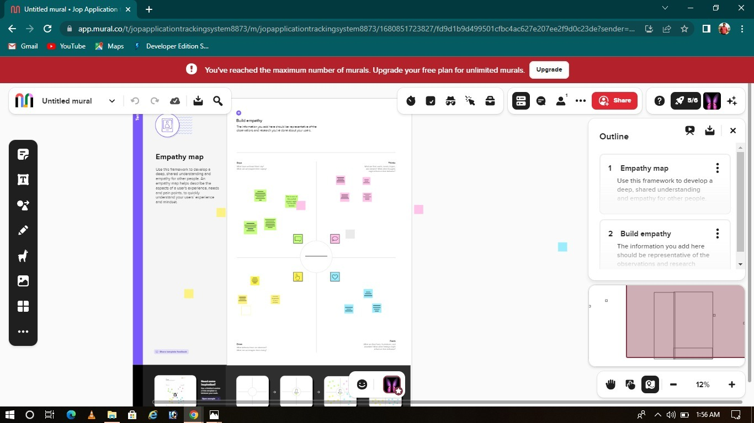

**2.2 Ideation & Brainstorming Map**

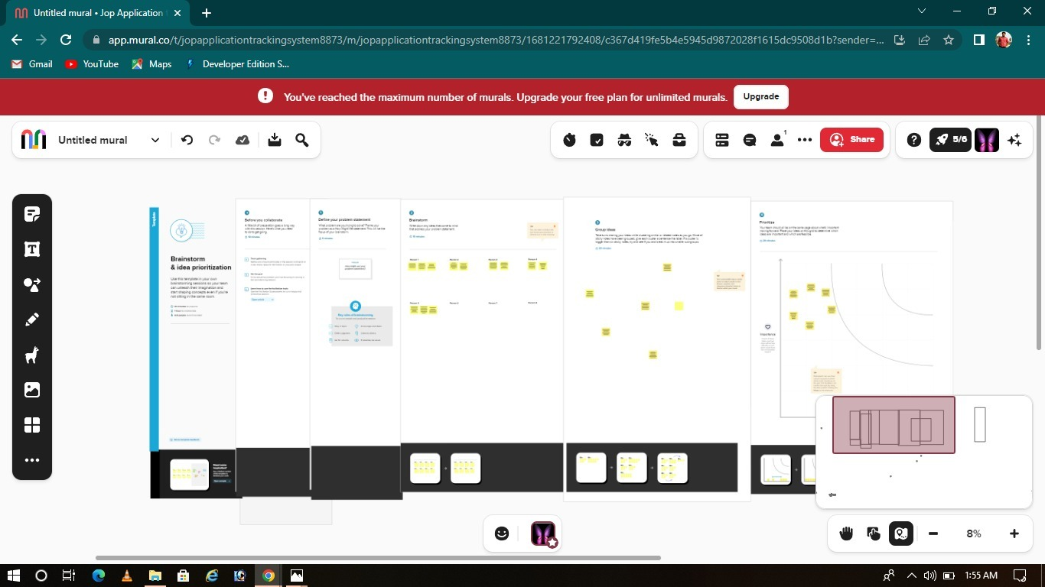

**3. RESULT**

**3.1 Data Model:**

|  |  |
| --- | --- |
| **Object Name** | **Field in the Object** |
| **Object Manager - 1** | |  |  | | --- | --- | | **Field Label** | **Data Type** | | Recruiters | Auto Number | | Recruiter | Auto Number | |
| **custom object- 2** | |  |  | | --- | --- | | **Field Label** | **Data Type** | | Recruiters | Auto Number | | Recruiters | Auto Number | |

**3.2 Activity & Screenshot**

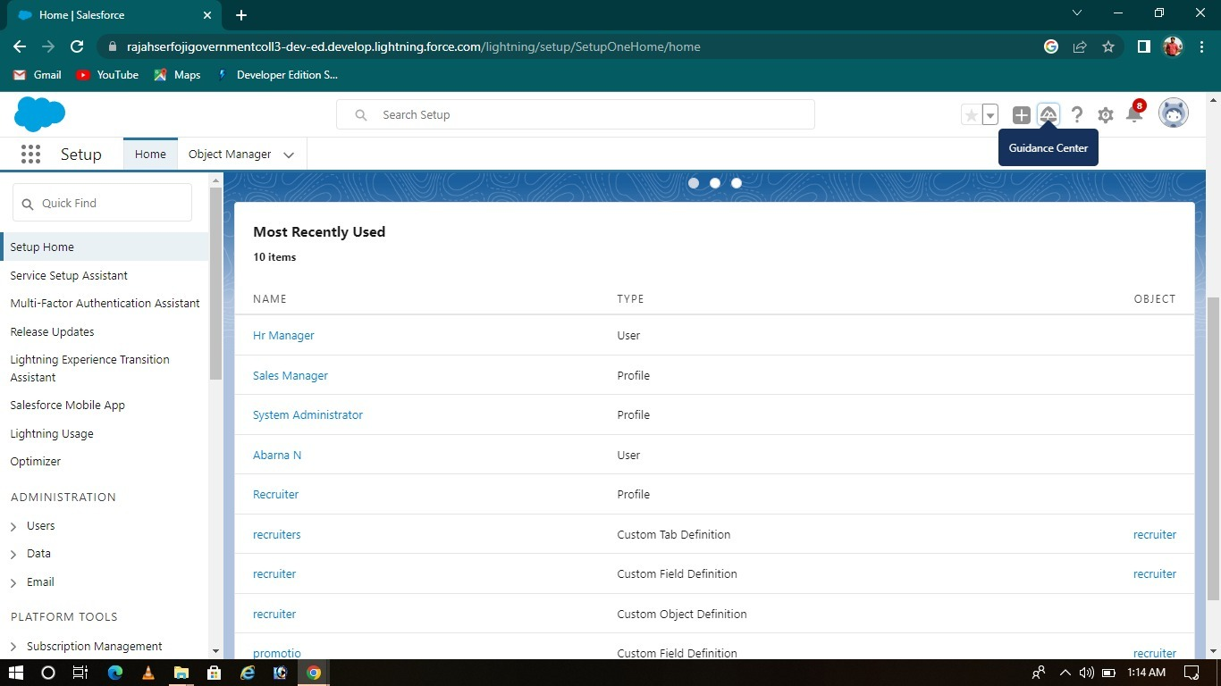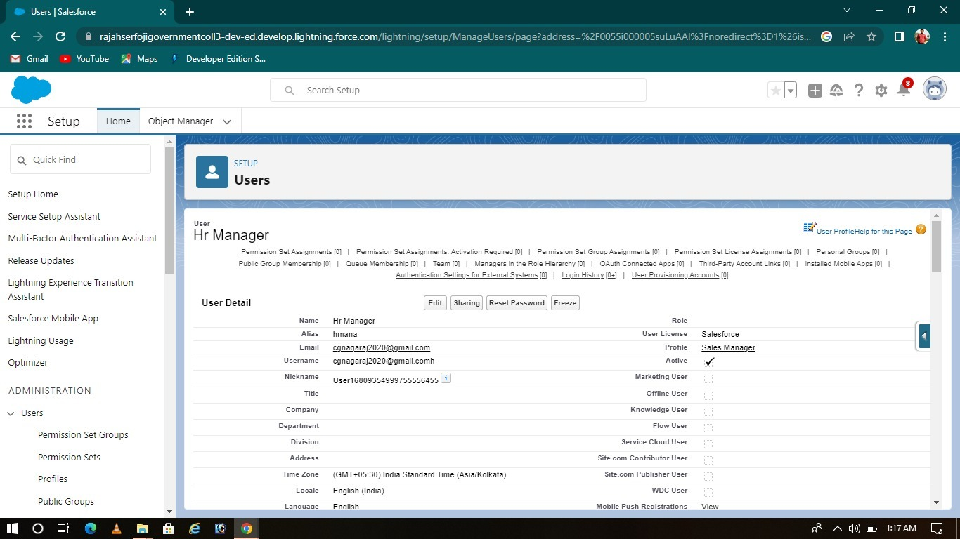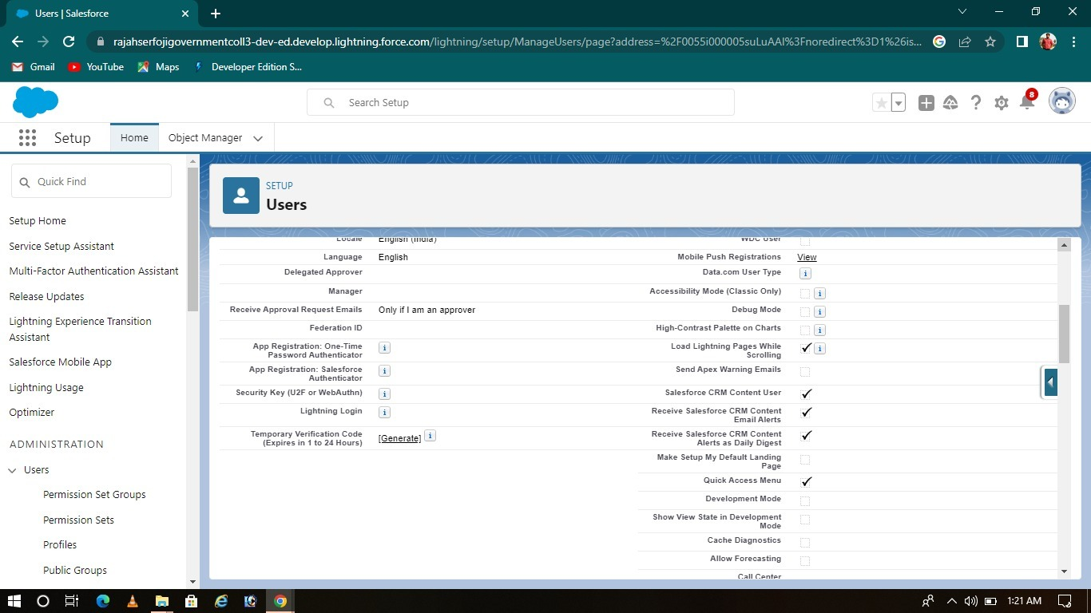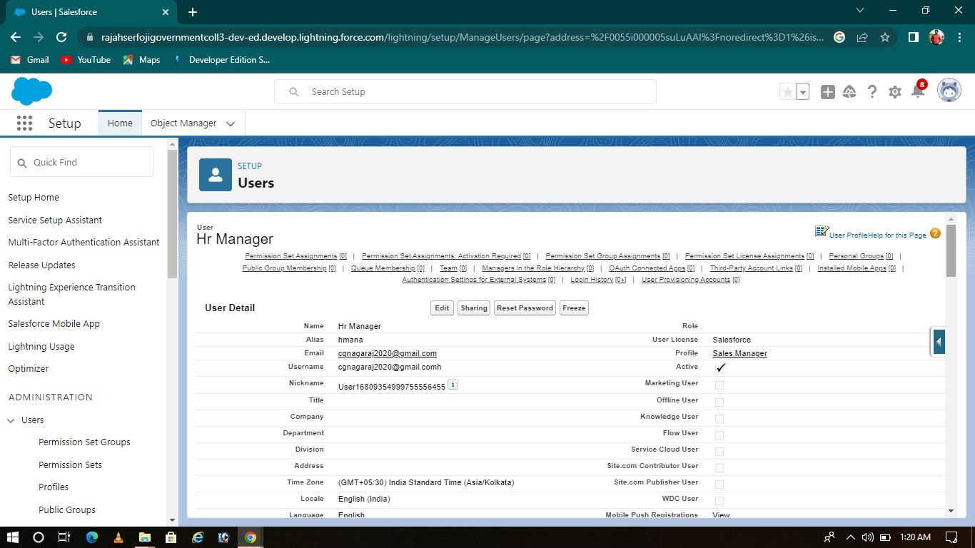

Dr

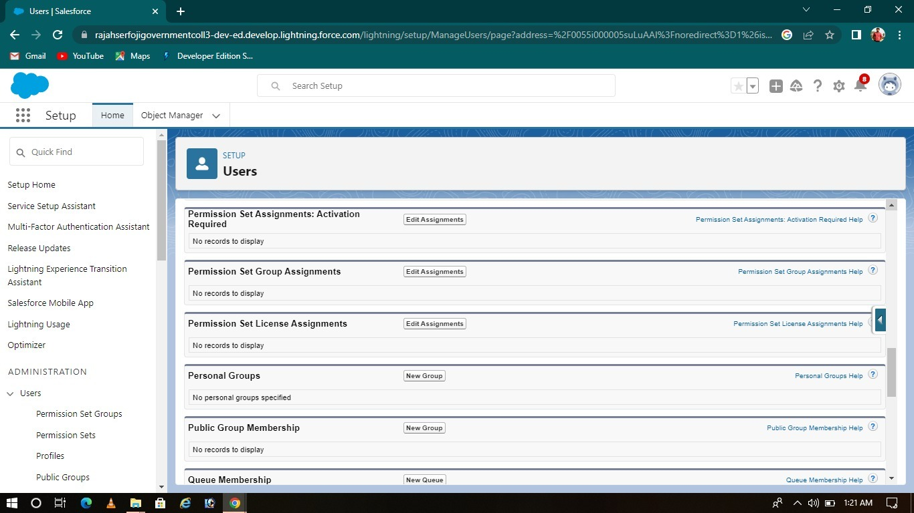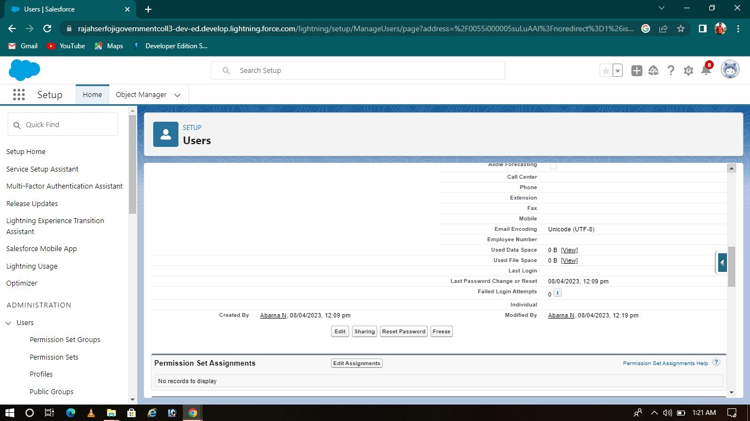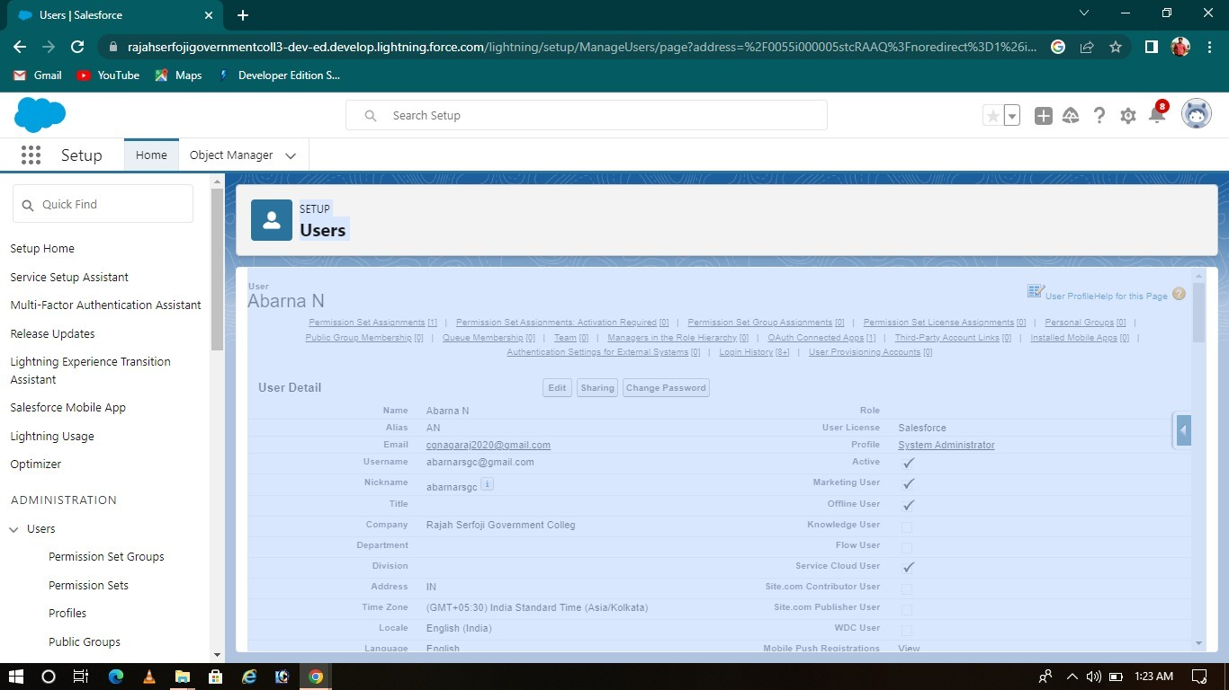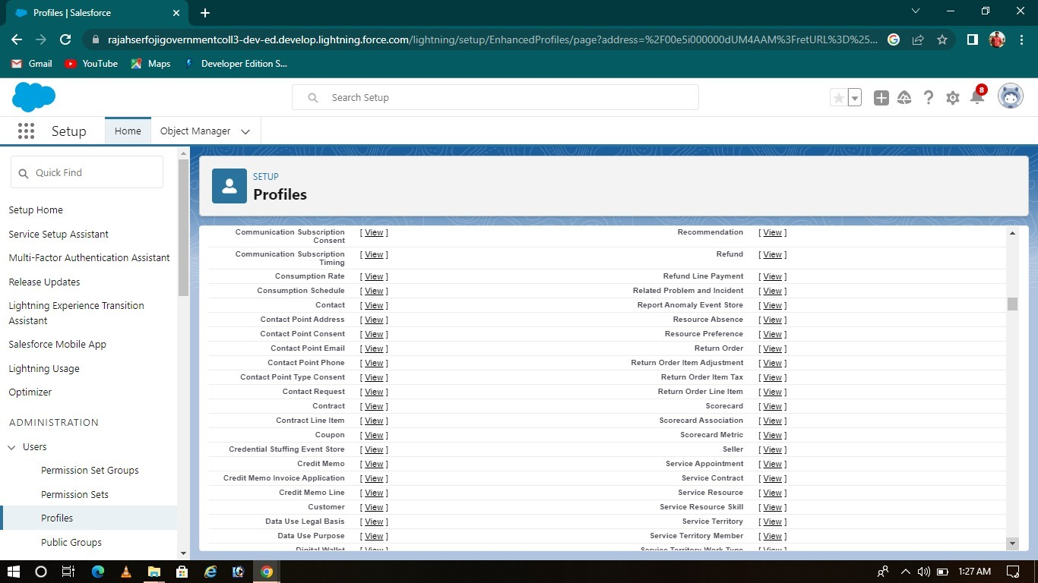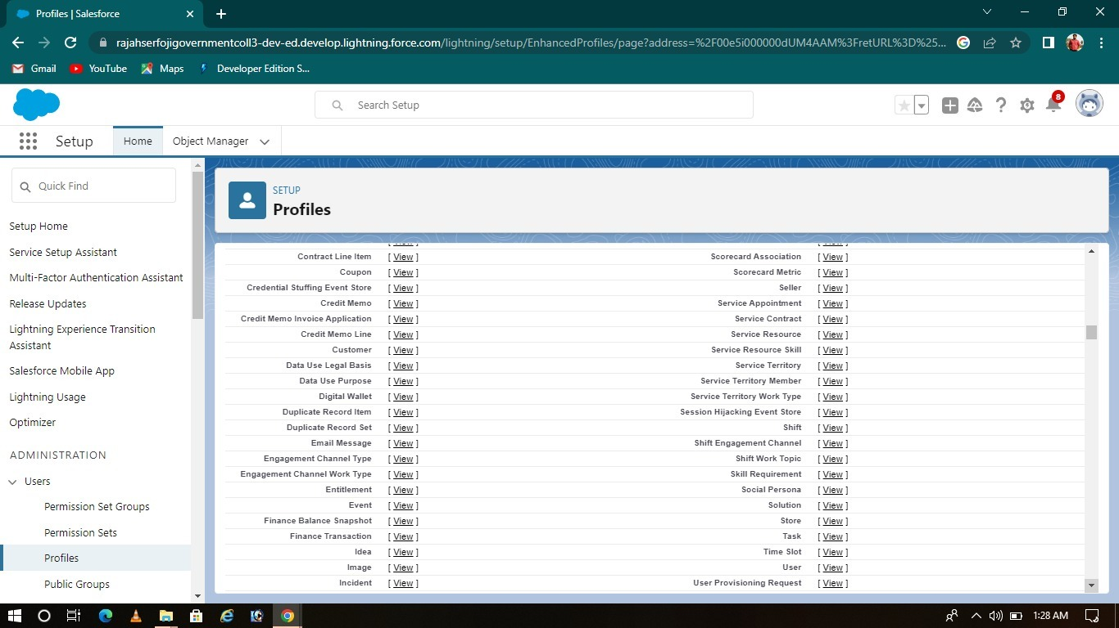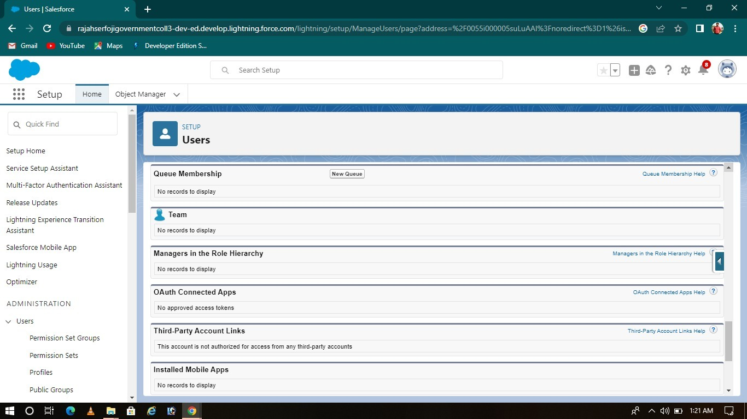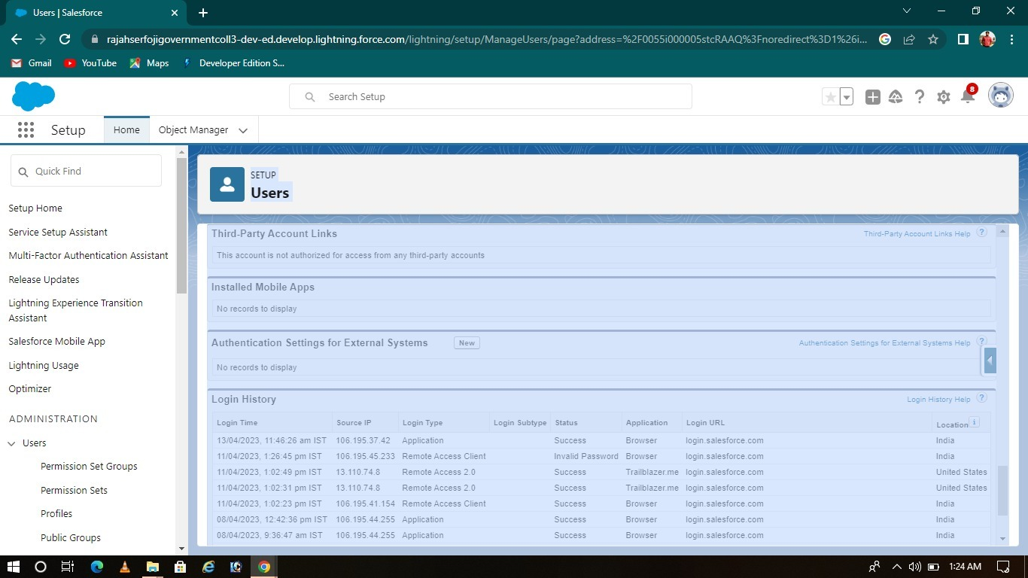

**4. Trailhead Profile Public URL**

**Team Lead 1-** <https://trailblazer.me/id/venim3>

**Team Member 2 --** [**https://trailblazer.me/id/abarn246**](https://trailblazer.me/id/abarn246)

**Team Member3 -** [**https://trailblazer.me/id/vimas6**](https://trailblazer.me/id/vimas6)

**Team Member 4–-** [**https://trailblazer.me/id/priye37**](https://trailblazer.me/id/priye37)

Team Member **5**- [https://trailblazer.me/Id/vidhk7](%20%20https://trailblazer.me/Id/vidhk7)

**5. ADVANTAGES & DISADVANTAGE**

**Advantages:**

* **Streamline hiring process**
* **Affordable**
* **Conserve time reduce drop**

**Off**

* **Avoid interview blunders**
* **Improving employee retention**

**Disadvantages :**

* **Resume pattern were entirely different for different candidates. So all data’s cannot be read by software.**
* **With handling recruitment, Valuable time is wasted in screening irrelevant applicants.**

**6. APPLICATIONS**

* **GPS tracking**
* **Person tracking**
* **Yard management**
* **Fleet management**
* **Real-time location system.**

(RTLS)

**7. CONCLUSION**

**I have felt that the project based on experimental learning program.**

**8. FUTURE SCOPE**

An ATS creates opportunities to automate manual processes, increase visibility into the hiring cycle for the entire recruiting team, and increase opportunities for communication throughout the candidate journey. 78% of recruiters using an ATS report that it has improved the quality of the candidates they hire.